1281. Subtract the Product and Sum of Digits of an Integer

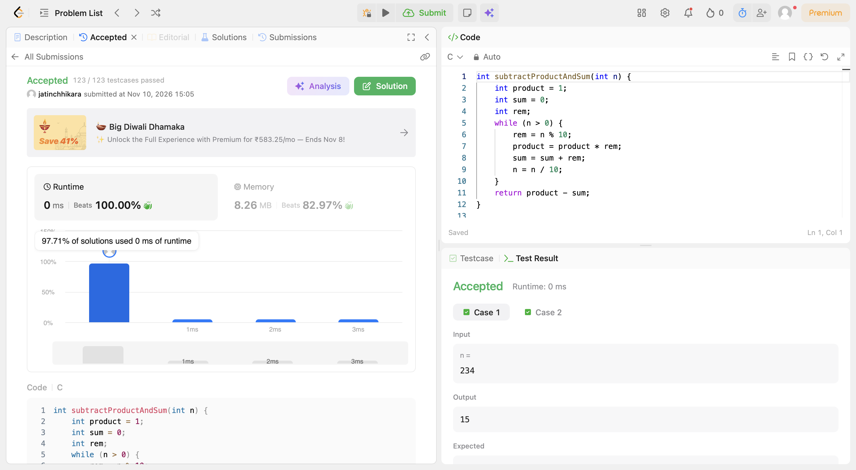
Code:
int subtractProductAndSum(int n) {
int product = 1;
int sum = 0;
int rem;
while (n > 0) {
rem = n % 10;
product = product * rem;
sum = sum + rem;
n = n / 10;
}
return product - sum;
}

